Body Systems FLIPBOOK
REQUIREMENTS
DUE DATE: _____________________
Create a flipbook of the Anatomy (structures) and Physiology (functions) of the Human body systems. This project will be completed during class and as nightly homework assignments. Use your class web site, textbook, notes, handouts and iPad research to complete this project.
Materials: 6 sheets of paper (4.25 x 11”), stapler, pens, pencils, markers, color printer, scissors, glue stick

Directions:
- Line up the 6 papers so that they are staggered tabs. Fold over to create a cover + 11 tabs. Staple close to the top.
- Label the cover and the tabs:
Cover: Human Body Systems Flipbook include the classification of humans (clip art below)
Human Body Systems’ tabs:
Skeletal
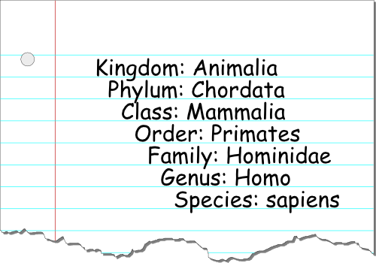
Muscular
Integumentary
Digestion
Circulatory
Respiratory
Urinary
Immune
Endocrine
Nervous
Reproduction
- Include a clip art diagram of each system
- Include a chart for Structure(s)
- Include a chart for Function(s) http://goo.gl/aVsFZs
The first system, Skeletal system, has been started for you:

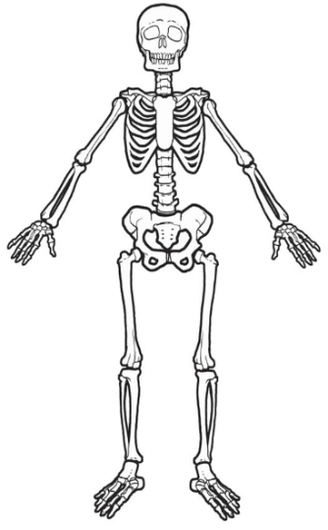
Functions:
Shape/ support; Protection of internal organs
Place for muscle attachment; Blood cell production; Storage of Minerals

Structures:
206 Bones joined at fixed and movable joints
Compact bone- dense outside bone
Marrow Cavity – fat storage in yellow marrow
Spongy bone – red marrow; blood cell production
Ligaments- connective tissue connects bone to bone
Tendons- connect muscle to bone
Cartilage- tissue that also covers the ends of bone for smooth movement

Functions:

Structures:

Functions:

Structures:

Functions:

Structures:

Functions:

Structures:

Functions:

Structures:

Functions:

Structures:

Functions:

Structures:

Functions:

Structures:

Functions:

Structures:

Functions:

Structures:

