Menu | Date  Event or Restaurant Name  Restauranteurs’ names:
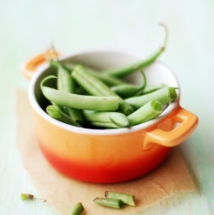  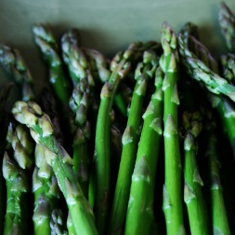  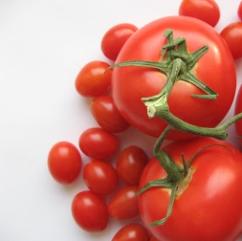 | Appetizer(s) names  Menu item description and nutrition info or how to make it healthier.  Main dish name  Menu item description and nutrition info or how to make it healthier.  Side dishes names’  Menu item description and nutrition info or how to make it healthier.  Dessert name  Menu item description and nutrition info or how to make it healthier.

Menu | Date  Event or Restaurant Name  Restauranteurs’ names:

Appetizer(s) names
Menu item description and nutrition info

Main dish name
Menu item description and nutrition info

Side dishes names’
Menu item description and nutrition info

Dessert name
Menu item description and nutrition info

Substitutions or deletions to make it a healthier choice:

